**Title of The Work**

P: ASSFP

ParaSpeak: A Speaking System for Paralyzed

**Diary Number**

16077/2021-CO/L

**Type of Work**

Literary/ Dramatic Work

**Language of Work**

English

**Submitted by**

**Nishit Mistry, Parth Joshi, Ms. Archana Chaugule, Mr. Harish Motekar**

Shah & Anchor Kutchhi Engineering College

Applicant and Author

# **Preface**

This work is a hardware application as a mountable device for communicating with the paralyzed person. This work, P: ASSFP ParaSpeak: A Speaking System for Paralyzed is henceforth addressed as P: ASSFP ParaSpeak: A Speaking System for Paralyzed or addressed as P: ASSFP or addressed as This work. P: ASSFP ParaSpeak: A Speaking System for Paralyzed or as a system is a speaking assistant for paralyzed people with minimal effort required from the person using the system. This work combines various modules of hardware and programming language. The programming language used is embedded C which helps in processing the data which the sensors have acquired from the working environment. P: ASSFP ParaSpeak: A Speaking System for Paralyzed, uses a sensor to gather the data of air blown by the user to interpret the message and display it on an LCD screen of size 20x4. This message is also sent to the person with the help of a Bluetooth application who is in the range of the Bluetooth module of the system and the sensor reading is also saved on the cloud for analysis purposes.

Implementation of the work is deployed on microcontrollers board - one customized Arduino Uno board and a NodeMCU board. P: ASSFP ParaSpeak: A Speaking System for Paralyzed uses the sound sensor KY-038, an analog sensor. This work also includes an LCD screen of 20x4 for the display of messages along with the Bluetooth module for sharing the data on mobile phones. The NodeMCU board is used to save the sensor readings on Cloud for doing analysis of the readings and making the system more efficient. Coding of this work is done on Arduino IDE, an integrated environment based on embedded C which contains all the required libraries and helps to deploy the developed code through the Arduino ISP into the microcontroller board. P: ASSFP ParaSpeak: A Speaking System for Paralyzed uses the method of collecting air blown by the user as analog data input and using the microcontroller board convert the data in the numeric format which is then matched with the appropriate message which the user is trying to convey in the LCD as well as the person which is in the periphery of the system. This work reduces the complexity and makes P: ASSFP ParaSpeak: A Speaking System for Paralyzed an easy to use and flexible system for paralyzed people.

**Index**

**Preface ii**

**Index iii**

**Chapter 1 – Introduction 1**

**1.1** **Background 2**

**1.2** **Motivation 3**

**1.3** **Background and Research Objectives 3**

**1.4** **Contribution 3**

**1.5** **Organisation of the Report 4**

**Chapter 2 - Literature Survey 5**

**Chapter 3 - ParaSpeak: A Speaking System for Paralyzed 7**

**Chapter 4 - Source Code of The Work 15**

**4.1** **Hardware and Software Configuration 15**

**4.2** **Algorithm 16**

**Chapter 5 - Conclusion 18**

**References 19**

# **Chapter 1 – Introduction**

**Everyone in the world has always imagined that machines and humans go hand in hand and help each other. This was one of the reasons why we thought to make this thing true and go one step ahead in this category. Paralyzed people have to face so many obstacles in their way that no one can ever imagine. They have to live their life as it is without any life. When they want something, they cannot just call someone like normal people and ask for it. Paralysis affects the motor neuron system of our body and makes it difficult to move our body. A brilliant mind like Stephen Hawking had this kind of disease which is also known as ​amyotrophic lateral sclerosis (ALS) or Lou Gehrig's disease. Stephen Hawking originally used spelling cards, indicating words with lifting eyebrows. There were many machines made which helped Hawking and we intend to do a similar invention but for a lower cost and a larger audience.**

**ParaSpeak - a mountable, easy to handle and use device which will identify the needs of a paralyzed person by classifying the different air blowing movement frequency from their mouth into a signal-based system and provide an appropriate message for the action performed. The sensor will detect this movement and the duration of the airwave, and take a decision which will be shown to the other person about what the paralyzed person needs at that instant with the help of an LCD screen.**

## **Background**

Paralysis causes the loss of motor function in the human by affecting the brain cells which are responsible for sending the signal to the muscle cells which causes the movement of the human body parts. A brilliant mind like Stephen Hawking had this kind of disease which is also known as amyotrophic lateral sclerosis (ALS) or Lou Gehrig's disease. Stephen Hawking originally used spelling cards, indicating words with lifting eyebrows. There were many machines made which helped Hawking and we intend to do a similar invention but for a lower cost and a larger audience. There are very few systems for the paralyzed person which help them to convey their thoughts. They often cannot convey the message of their daily chores, which makes life far more complex for them.

Many systems try to collect the electric signal which our brain sends to our speaking system and interpret from that signal the message as the speaking system is not working properly or many a time not working at all for the paralyzed person.

Introduction of the artificial sensor i.e. the sensor continuously collects the data from the environment helps to perceive things similarly as perceived by the human through their natural sensor. The data collected by the artificial sensor or electronic sensor can be the analog data signal or the digital data signal. This data is processed by the microcontroller board which converts this signal information into the numerical format which helps to achieve specific tasks.

Many sensors have been developed and used to develop the system of paralyzed people, some of them are IR sensors, Motion sensors, Electroencephalogram sensors, etc. The code for the sensor data input and manipulation of this data is done by a programming language one of which is embedded C. The code written for the sensor and the microcontroller board which does the processing is deployed with the help of AVRISP for the AVR board, USB programmable chip, etc.

## **Motivation**

Nowadays, many researchers are focusing on medicinal research for helping patients who are suffering from various diseases. We are focusing on patients who are severely affected by Paralysis & face a tough time in doing day-to-day routines. Hence, an Arduino-based system will be efficient for complete monitoring & response from the patients to the family members, friends, relatives, etc. We always wanted to make our society a better place by using the various tools at our disposal, hence, we are developing this project.

## **Background and Research Objectives**

The main aim of this system is to help the paralyzed patient convey their message easily. The system has various sensors & hardware components like Sound Sensors, Bluetooth Module, Microcontroller Board, etc. The system aims at conveying multiple messages for the paralyzed patient on the LCD Screen & the mobile phone of the relative or family member. This message will be based on the frequency & pattern of the blowing of air by the paralyzed patient. They will blow air into the sound sensors & they will categorize it and display the message. This will be simple to make the paralyzed patient learn & won’t be a tedious job.

## **Contribution**

We have used multiple high-quality sensors & deployed an easy-to-use mechanism that makes the system helpful for the paralyzed patients. More than this, this system can also be used & modified as per some different diseases and it will be helpful to that particular disease as well. We have developed a full-fledged Arduino Code that is simple to understand & does the job exceptionally. Connections are equally simple & the project makes it efficient for the hospitals or NGOs to deploy into the real world.

## **Organisation of the Report**

Background, research objectives, and contributions are discussed in Chapter 1. Various medicinal live approaches are surveyed in Chapter 2. The overview of our system and its related literature, the future scope, designing of the system, components used, understanding thoughts, and message demonstration are described in Chapter 3. The system configurations are mentioned in Chapter 4 & Concluding remarks are made in Chapter 5 and references are listed.

# **Chapter 2 - Literature Survey**

Advancement in technology has brought many devices, but the one which was widely used and is still in existence is a spelling device that uses slow cortical potentials of electro-encephalograms to operate its system. This system consists of a screen with a cursor on it and the alphabets which can be selected with the help of the cursor. This requires the person to go through long-term training and practice to get an acquaintance of the system. The training was continued till the accuracy of 75% or more was achieved. The research applied to the system revealed a rate of 2 characters per minute to be selected by a person suffering from amyotrophic lateral sclerosis. [2]

Another system uses Electroencephalogram (EEG) sensors to capture the thoughts and then transform them into the appropriate form to assist the patient's post-stroke and rehabilitation. The system uses the approach of deep learning for feature extraction, pre-processing, and classification. This is a complex system but can be widely used post-stroke. [3]

A system has been developed which is a wearable device that uses the concept of a silent speech interface to convey the message produced in the thought process by collecting the neuromuscular signal from the skin surface. It can be used to deliver confidential communication as well as control IoT devices. The architecture as well as its usability in the medical field is yet to be discovered. [4, 11]

The eyeblink IR sensor is used to develop a project where a paralyzed person can perform the communication with the blink of an eye. The blinking of the eye is captured by the sensor. This system is implemented mostly in goggles and additional sensors provide monitoring support for patients to the system. The usability of this system is reduced in its implementation process and thus reduces its feasibility. [5]

[6]A hand or gesture control system is mostly implemented for the person suffering from partial paralysis. The motion of hands is captured by the motion sensor provided to the controlling board to convert into appropriate messages. This system believes that the person can move one of its limbs to capture the motion. The current system provides a solution to many aspects of the problem but one aspect which these systems tend to ignore is a system for the completely paralyzed person which requires the following aspects are not covered:

**Easy Interface: -** A person suffering from paralysis requires an easy interface with less burden to operate the system.

**Cost Efficient: -** The system should be easily accessible to wide classes of people in a cost-efficient manner.

**Less Complexity: -** Accessing the system by both the suffering person and interpretation by its family members should involve less complexity.

**Easy Message Convey: -** Simple system which can help to convey the essential message to the person taking care of the paralyzed person is required so that the need of the paralyzed person can be fulfilled easily.

# **Chapter 3 - ParaSpeak: A Speaking System for Paralyzed**

ParaSpeak is a mountable device that will help the paralyzed people to tell their needs by just blowing air at different frequencies. Our system is going to use the KY-038 Microphone sound detection module. For sound detection module has two outputs:

**1. AO - Analog Output**, the real-time output voltage signal of the microphone. Direct microphone signal as a voltage value.

**2. DO - Digital Output**, when the sound intensity reaches a certain threshold, it outputs high and low signals. You can use a potentiometer to configure an extreme value for the sonic. If the value exceeds the extreme value, it will send a signal via digital out.

The threshold sensitivity can be adjusted via a potentiometer on the sensor. This module consists of a sensitive capacitance microphone for detecting sound and an amplifier circuit. The output of this module is both analog and digital. The digital output acts as a key, and it activates when sound intensity has reached a certain threshold. The sensitivity threshold can be adjusted via the potentiometer on the sensor. The analog output voltage changes with the intensity of sound received by the microphone. You can connect this output to Arduino analog pins and process the output voltage. [7]

ParaSpeak is different from the other solutions available in the market as it tries to conquer the drawbacks of all the different systems and keep its work in the right place. As we know, the cursor system is good but it requires large training for the patient which will make them tired just learning the system. Our system is not going to be that hard to learn and is fairly very easy. Another system that uses the neuromuscular muscles signals from the skin surface is a great invention. But, it is of very little use for the paralyzed person and the person who has to understand (interpret) because they both need to buy the system and learn to operate it. [2]

[5]The eye blinking system is not feasible due to some of the components like the IR sensor which may calibrate a false reading due to some interfering waves. Also if the person blinks normally, the system would interpret it as some signal by the patient and will provide the message about that signal, which would not be a true output that was expected. [6]The hand gesture system using a glove can only help those people who can still move their hands and make movements and gestures with them. But, if the patient is completely paralyzed with just having their respiratory system working, then the hand gesture system will also fail miserably.

ParaSpeak tries to overcome all of these different drawbacks faced and uses a rather simple approach and cost-efficient way to design a system for the paralyzed to make their life easier.

* 1. ***Understanding Thoughts***

The human brain sends signals through the neurons to produce speech, this signal is forwarded to the vocal cord which lets the human speak what they are thinking. In the case of the paralyzed person, all these senses are not in working condition, so producing voice is difficult for them. Understanding what they want to speak is a difficult task as the neurons are not responsive, but a paralyzed person can indicate the message by blowing the air from their mouth. Breathing is a fundamental function that is required to live. The air blown from the mouth can be varied by the paralyzed person which could help as an indicator for any message. [15]

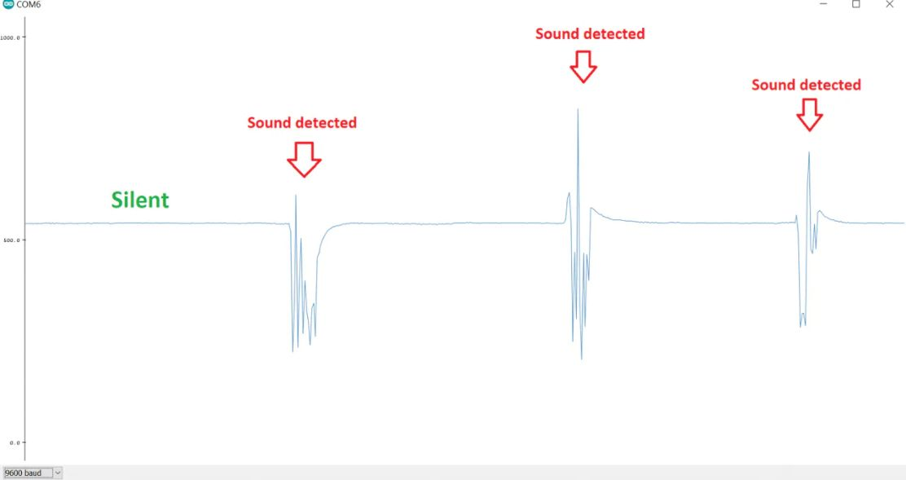

Figure 1. Sound detection at various frequency

[10] The variation in the air blowing concerning its amplitude and frequency can be captured by the sensor and this can help to understand what the person wants to say. The paralyzed person needs basic training to get started with the system, it should know the label associated with a particular air blowing frequency. [12, 13] To make the system easily learnable to the person, the message associated with the frequencies will be widely spread. The paralyzed person can convey the message by blowing the air in a frequency associated with the message. Any movement of air in the area of a particular frequency can be detected by the sensor. The signal is then sent to the microcontroller board which analyses these frequencies and provides the associated output. [16] The frequency and the message associated with it can be adaptive i.e. it can be changed according to the person with the assistant of the technical in charge. This method of analyzing the thoughts will work as a helping assistant for the paralyzed person to convey the daily necessity messages to his/her family members.

* 1. ***Frequency Analysis & Processing***

The air will be blown by the paralyzed person in different frequencies according to the message they want to say. So, the analysis of these different frequencies becomes an integral part of our solution system. The KY-038 Microphone sound detection module is going to take all the needed frequencies from the paralyzed patient and send them to the microcontroller board. The technician in charge will set these multiple different frequencies according to the messages required by the family and the paralyzed person. Less air blown for a short period will correspond to a lower frequency and greater air blown for different amounts of time will correspond to multiple different frequencies set in the system. The frequency analysis will be done as mentioned above.

[10] The frequency analysis is an important step, but for the system to work, we need to process the information as well. The frequency processing will be another integral step to the overall system. This step will correspond to the generation of output based on the multiple different inputs. Some input generated by the patient will be analyzed, put into some category, go into the processing part in the microcontroller board, which then will generate a corresponding output and finally display it on the LCD Screen. [9] This will help the paralyzed person and their family to communicate much more effectively rather than moving some parts of their body, or blinking their eyes. The Audio signal from the output of the amplifier is a varying voltage. To measure the sound level, we need to take multiple measurements to find the minimum and maximum extents or "peak to peak amplitude" of the signal.

* 1. ***Demonstrating Messages***

The processed signal is converted into the numerical form, which is now passed to the code which checks with the various labels of frequencies of messages, and output of this further passed to the LCD controller which displays the message in the understandable language. Now, two cases may exist, where the person is in front of the paralyzed person and can read the message and provide the thing which is needed. The second case is where the person is not at home, in this case, the message will be sent in the form of Text-message to the registered family member's phone number. In this case, the system is useful where the paralyzed person's family is nuclear and are working personnel. They can be made known about any important situations related to the paralyzed person's health. Many times, it is not possible to take constant care of the paralyzed person, in this case, the message on the phone can help them to fulfill the paralyzed need. In any of these cases, this system takes the utmost care of the paralyzed person. It provides all the necessary as well as some additional features which can reduce the communication gap between the paralyzed person and their family members. [11]

* 1. ***Use Case Diagram***

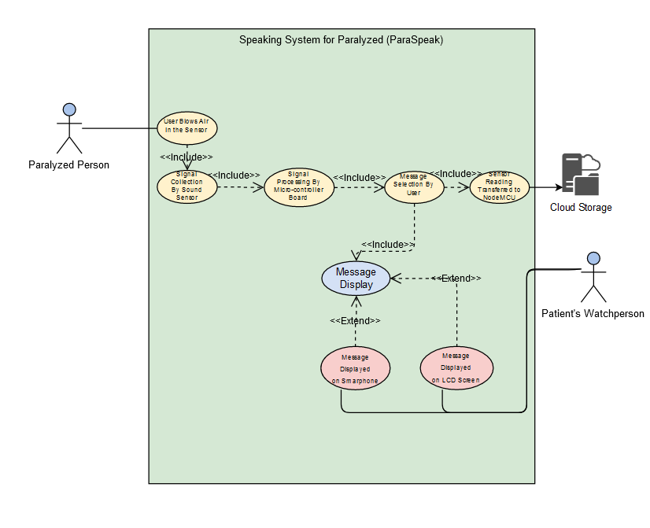

Figure 2. Use Case Diagram

The workflow of the system can be perceived through the use-case diagram above. The system is initiated with the paralyzed person blowing air in the sound sensor KY-038. The signals are generated based on the intensity and frequency of the air blown. The generated signals are sent further to the microcontroller board which performs the further processing of the signals. These signal values will move in 2 ways - One is to go into the NodeMCU board from the Uniko Ekam Board and use the Wi-Fi module on the NodeMCU board to store the data on Cloud for analysis purposes and the second way is the signals get allotted to their respective message labels. The labels for the signals are fed to the LCD. LCD provides the output message which can be perceived by the person taking care of the paralyzed person and provides the necessary help required. This will provide an assistant through which one has to not always be present in front of the system to read the message from the LCD screen and provide assistance. The message will be sent & read from the mobile phones with the help of Bluetooth technology and immediate help can be provided to the paralyzed person.

* 1. ***Components Used***

1. **Uniko Ekam Microcontroller Board –**

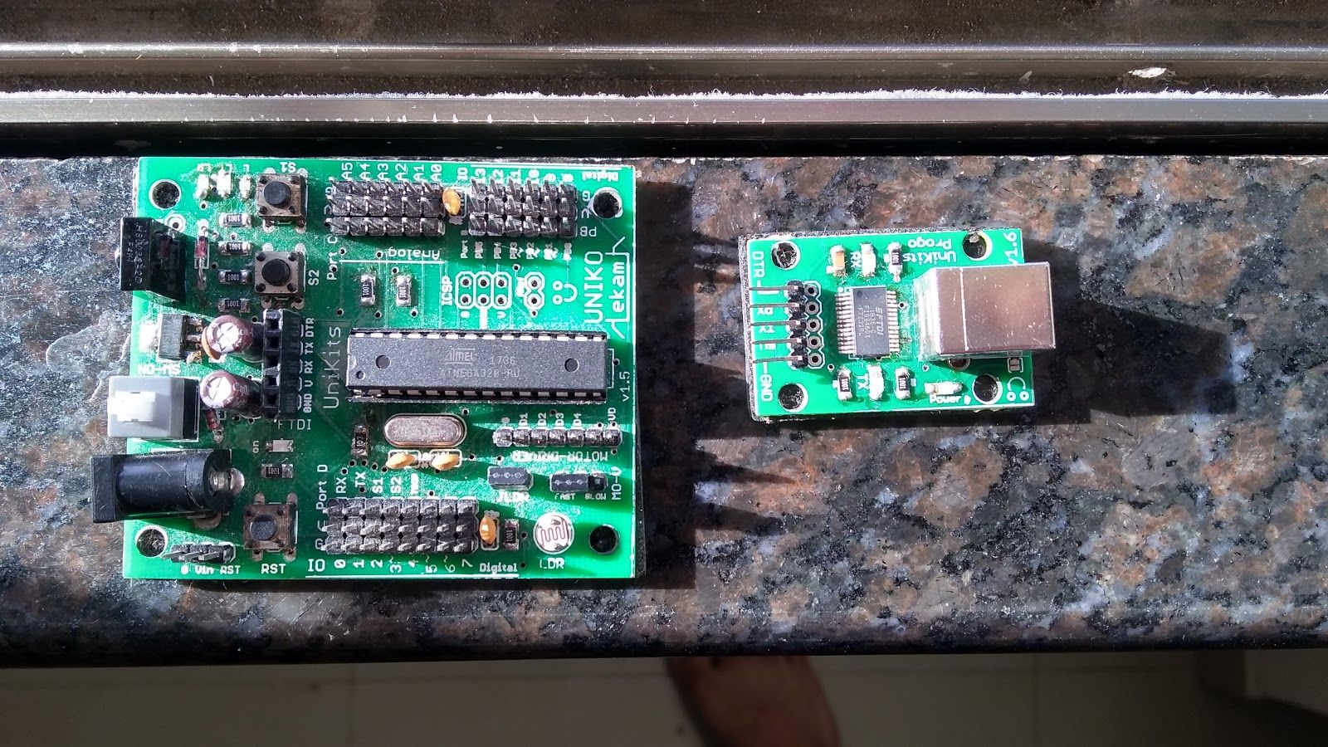

Figure 3. Uniko Ekam Microcontroller Board

A very similar board to Arduino Uno. This board just has more Vcc and GND pins than Arduino Uno. The Microcontroller is the same ATMEGA328P with 14 Digital Pins and 6 Analog Pins.

1. **KY-038 Microphone Sound Detection –**

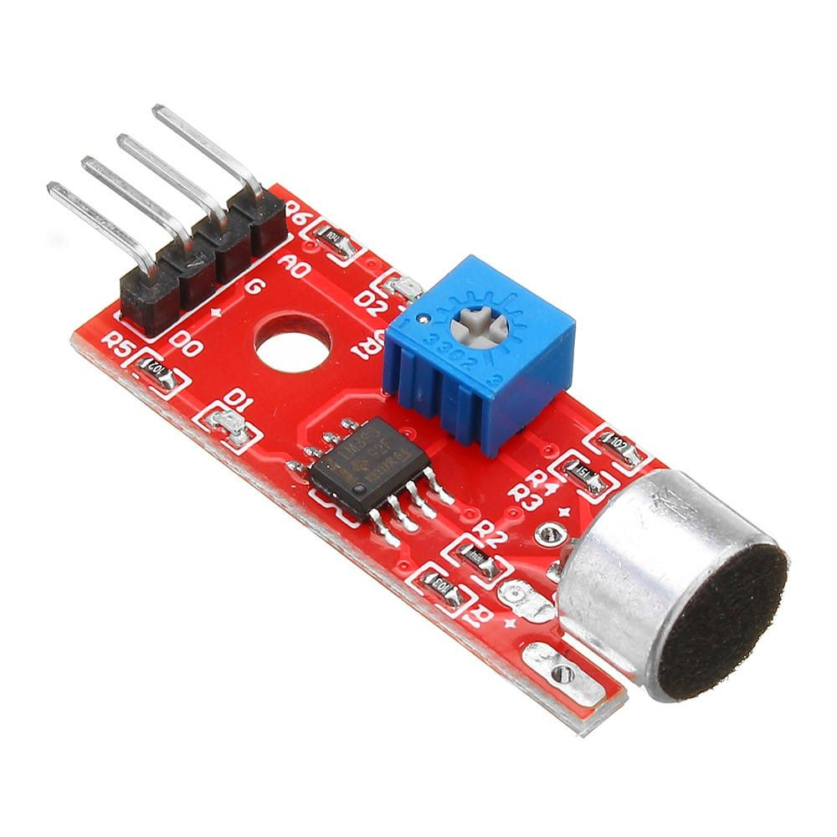

Figure 4. KY-038 Microphone Sound Detection

KY-038 is a Microphone sound detection module. It has 4 pins - AO (Analog Out), DO (Digital Out), Vcc, and GND.

1. **20*4 LCD Screen –**

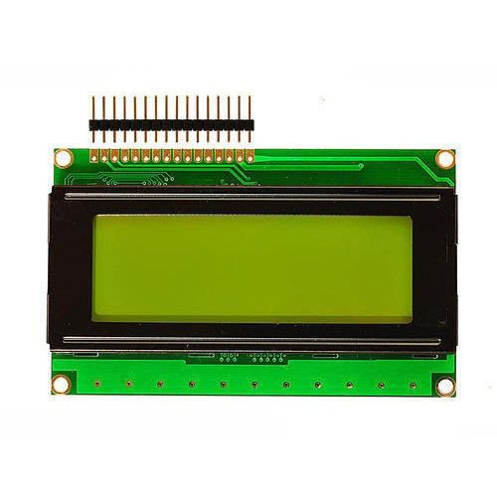

Figure 5. 20*4 LCD Screen

A 20*4 LCD means it can display 20 characters per line and there are 4 such lines. In this LCD each character is displayed in a 5x7 pixel matrix.

1. **NodeMCU –**

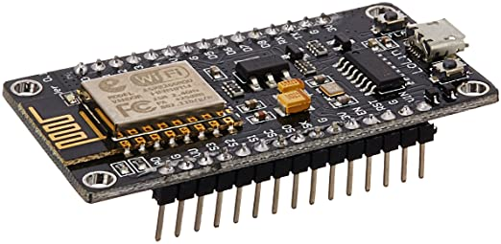

Figure 6. NodeMCU Board

NodeMCU is a low-cost open-source IoT platform. It initially included firmware that runs on the ESP8266 Wi-Fi SoC from Espressif Systems and hardware that was based on the ESP-12 module.

## **Future Scope**

The speaking assistant system provides all the necessary features which are essential for its complete functioning. But few remaining areas can be explored to further add more advanced features into the system:

1. Health monitoring sensors can be added to provide the remote health analysis of the paralyzed person.
2. A sensitive and more advanced sound detection sensor available in the future can be used to provide more accuracy.
3. Deeper analysis of the sound signals can be done, which would help to allocate more labels to the sound signals.
4. Testing the system on more and more people can help to evaluate the real-time functionality of the system and eliminate the errors that may arise.

# **Chapter 4 - Source Code of The Work**

The ParaSpeak: A Speaking System for Paralyzed was developed in the following environment. The algorithm is described in subsequent sections.

## **Hardware and Software Configuration**

**Hardware Configuration**

**Processor**: Intel(R) Core(TM) i5-8250U CPU @ 1.60GHz

**Memory**: 8 GB RAM

**Disk Space**: 1 GB  
 **GPU:** Nvidia GeForce MX150 (2 GB)

**Software Configuration:**

Arduino 1.8.15

## **Algorithm:**

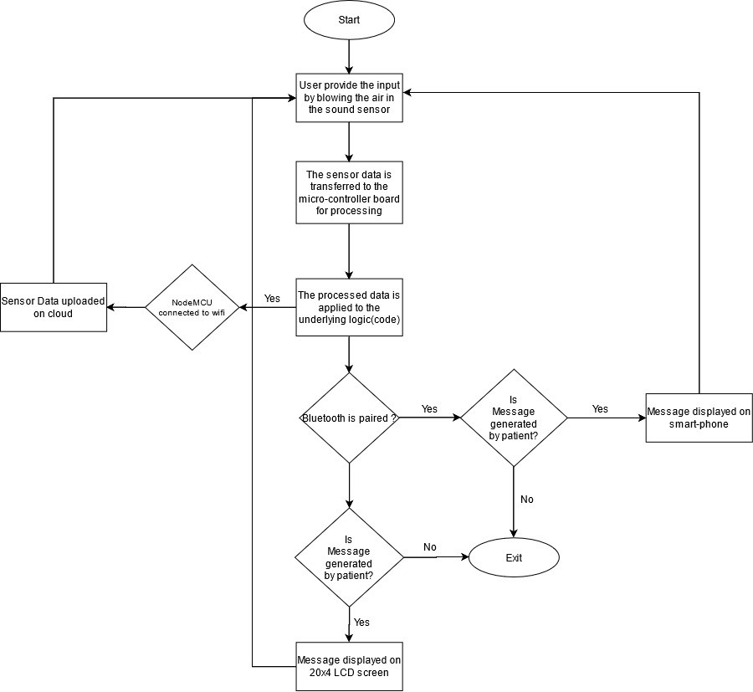

Figure 7. Algorithm

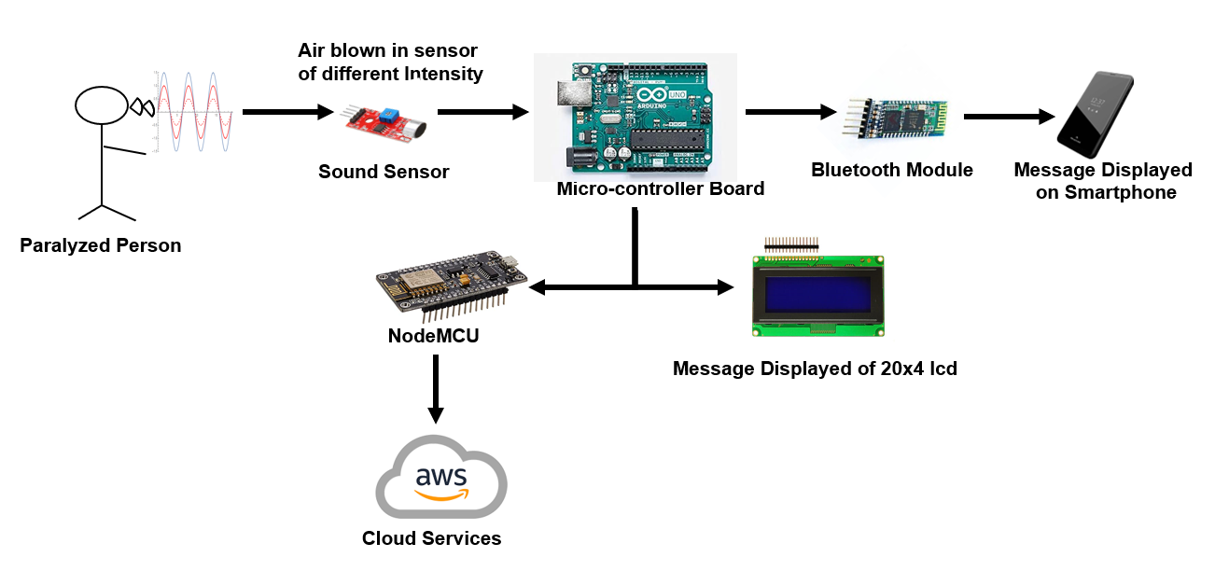

Figure 8. Algorithm

# 

# 

# 

# 

# 

# 

# **Chapter 5 - Conclusion**

P: ASSFP ParaSpeak: A Speaking System for Paralyzed based on the microcontroller board of Arduino Uno, which is small in size, cost-efficient, and a flexible solution for our system. One of the problems which are faced by the person suffering from the paralysis is its inability to perform the daily operation i.e. They require the help of another person and conveying the things which the paralyzed person wants to perform becomes a very difficult job for them. So our work helps the paralyzed person to perform the daily chores with minimal effort required on the user side.

This system is a wearable device that can always be with the paralyzed person and assist him/her by forwarding their needs to the concerned person. It also uses Bluetooth technology to forward the message. The User Interface of the smartphone application that takes the message from the Bluetooth module of the microcontroller board and displays it onto the phone is simple. It helps the person to get the message directly so immediate help can be provided to the paralyzed person. The cloud analysis will also prove to be very much beneficial in future updates to this system.

ParaSpeak is an assistant system that will help the family members to understand the thoughts of the paralyzed person to fulfill their needs and will also allow them to concentrate on their other work with the help of the messaging assistant. The system tries to fulfill the communication gap which exists between the paralyzed person and the person taking care of them and provides a very cost-efficient and easy-to-use system through the help of modern technologies.

**References**

1. *Arnav Kapur, Shreyas Kapur, Pattie Maes, AlterEgo: A Personalized Wearable Silent Speech Interface, IUI 2018, March 7–11, 2018, Tokyo, Japan.*
2. *Sunil Jacob, Varun G. Menon, Fadi Al-Turjman, Vinoj P. G., Leonardo Mostarda, Artificial Muscle Intelligence System with Deep Learning for Post-Stroke Assistance and Rehabilitation, ​DOI 10.1109/ ACCESS.2019.2941491, IEEE Access.*
3. *Prof. R.K.Moje, Abhijeet Botre, Sumit Pakhare, Vikas Tupe, Assisting System for Paralyzed, ​INTERNATIONAL JOURNAL OF INNOVATIVE RESEARCH IN ELECTRICAL, ELECTRONICS, INSTRUMENTATION AND CONTROL ENGINEERING Vol. 4, Issue 5, May 2016.*
4. *S. A. C. Aziz, A. F. Kadmin, N. Rahim, W. H. W. Hassan, I. F. A. Aziz, M. S. Hamid, R. A. Hamzah, Development of automatic healthcare instruction system via movement gesture sensor for paralysis patients, IJECE - Vol. 9, No. 3, June 2019, pp. 1676~1682. ISSN: 2088-8708, DOI: 10.11591/ijece.v9i3.pp1676-1682.*
5. *Syed Faiz Ahmed, Syed Muhammad Baber Ali, Sh. Saqib Munawwar Qureshi, Electronic Speaking Glove for Speechless Patients - A Tongue to a Dumb, 978-1-4244-7503-2110/$26.00 ©2010 IEEE.*
6. *Safayet Ahmed; Rafiqul Islam; Md.Saniat Rahman Zishan; Mohammed Rabiul Hasan; Md.Nahian Islam, Electronic Speaking System for Speech Impaired People: Speak Up, 978-1-4673-6676-2/15/$31.00 ©2015 IEEE.*
7. *Stefan Schütz, Bernhard Weissbecker, Hans E. Hummel, Karl-Heinz Apel, Helmut Schmitz, Horst Bleckmann, A spelling device for the paralyzed, ​NATURE | VOL 398 | 25 MARCH 1999 |* [*www.nature.com*](http://www.nature.com)*.*
8. *Servick, Kelly. “AI Allows Paralyzed Person to ‘Handwrite’ with His Mind.” ​Science, 2019, doi:10.1126/science.aaz9606.*
9. *Karagoz, Yurdagul, et al. “An EOG Based Communication Channel for Paralyzed Patients.” ​2017 25th Signal Processing and Communications Applications Conference (SIU), 2017, doi:10.1109/siu.2017.7960371.*
10. *Kharaje, Narayan P., et al. “Digital Pen for Paralyzed Patient.” ​2016 International Conference on Communication and Signal Processing (ICCSP), 2016, doi:10.1109/iccsp.2016.7754503.*
11. *Traylor, Stephanie. ​Paralysis. CreateSpace, 2012.*
12. *Tooker, Robert Newton. ​The Home Treatment of Paralysis. Gazette Co. Print, 1871.*
13. *Cullen, Charlie. “Arduino Audio Control.” ​Learn Audio Electronics with Arduino, 2020, pp. 376–425, doi: 10.4324/9780429197499-10.*
14. *Lapono, Laura Anastasi Seseragi, and Redi Kristian Pingak. “Design of Sound Level Meter Using Sound Sensor Based on Arduino Uno.” ​Jurnal ILMU DASAR, vol. 19, no. 2, 2018, p. 111, doi:10.19184/jid.v19i2.7268.*
15. *Li, Yun. “12 Detection Using Sound Sensors.”doi:10.32469/10355/6651.*